**Department of Industrial and Systems Engineering**

**Indian Institute of Technology, Kharagpur**

**Simulation Lab**

**Time-2:00 pm to 5:00 pm Date: 22/01/2021**

**__________________________________________________________________**

**Demonstration problem**

1. The logical structure of a model representing a portion of a manufacturing facility is shown in fig.1. "Blank" parts arrive to a drilling center with inter-arrival time following **Expo (5)**, are processed by a single drill press with **TRIA (1,3,6)**, and then leave. If a part arrives and finds the drill press idle, its processing at the drill press starts right away; otherwise, it waits in a First-In First-Out (FIFO) queue. (Replication length: 20 minutes, No. of replications: 5).

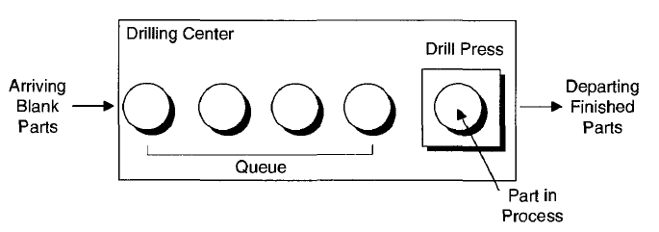

Fig.1 A simple processing system

**Goals of the Study**

* The average waiting time in queue of parts that enter service at the drill press during the simulation.
* The maximum waiting time in queue of parts that enter service at the drill press during the simulation.
* The time-average number of parts waiting in the queue (again, not counting any part in service at the drill press).
* The maximum number of parts that were ever waiting in the queue.
* The average and maximum total time in system of parts that finish being processed on the drill press and leave.
* The utilization of the drill press, defined as the proportion of time it is busy during the simulation.

1. Modify problem 1 with all of the following changes:
2. Add a second machine to which all parts go immediately after exiting the first machine for a separate kind of processing (for example, the first machine is drilling and the second machine is washing). Processing times at the second machine are independent of those from the first machine but drawn from the same distribution as for the first machine. Gather all the statistics as before, plus the time in queue, queue length, and utilization at the second machine.
3. Immediately after the second machine, there's a pass/fail inspection that takes a constant 4.5 minutes to carry out and has and 75% chance of a passing result; queueing is possible for the single inspector, and the queue is first-in, first-out. All parts exit the system regardless of whether they pass the test. Count the number that fail and the number that pass, and gather statistics on the time in queue, queue length, and utilization at the inspection center.
4. Run the simulation for 480 minutes instead of 20 minutes.

**Practice Problems:**

1. Consider a loan application office where application arrive at exponentially distributed inter arrival time with mean 1.25 hours; the first application arrive at time zero. The processing of each loan applications requires four steps: Check credit, prepare agreement, deciding the loan price and disburse funds. For each application the steps have to be done in that order. Each step takes expo (1 hour), independent of the other steps and of the arrival process. Initially the system is empty and idle. Run for 160 hours and find the performance measures:
2. Average and max no. applications in process (WIP);
3. Average and max total time in system of applications.

There are four employees (Alfie, Betty, Chucks, and Doris) available, equally qualified and each can do any process step.

Case 1: Consider each employee is assigned for a particular step.

Case 2: Consider each employee completely processes all four steps of one application at a time before moving onto the next application in the queue.

Compare both the cases with respect to performance measures.

1. In Demonstration Problem 2, suppose that parts that fail inspection after being washed are sent back and re-washed, instead of leaving; such re-washed parts must then undergo the same inspection, and have the same probability of failing (as improbable as that might seem). There's no limit on how many times a given part might have to loop back through the washer and inspector. Run this model under the same conditions as Exercise 3-6, and compare the results for the time in queue, queue length, and utilization at the inspection center (add a brief Text box to your .doe file for this comparison). Of course, this time there's no need to count the number of parts that fail and pass, since they all eventually pass (or do they?). You may have to allow for more room in some of the queue animations.
2. In the previous problem, suppose the inspection can result in one of three outcomes: pass (probability 0.75, as before), fail (probability 0.11), and re-wash (probability 0.14). Failures leave immediately, and re-washes loop back to the washer. The above probabilities hold for each part undergoing inspection, regardless of its past history. Count the number that eventually fail and the number that eventually pass, and gather statistics (in a Text box in your model) on the time in queue, queue length, and utilization at the inspection center. (HINT: Explore the Decide flowchart module and contemplate a higher-dimensional coin to flip.)